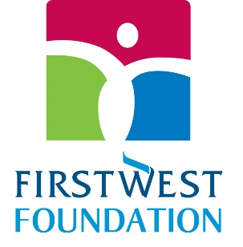

2023 Envision Financial Employees’ Endowment Awards $18K in Grants

$1,600 – Cyrus Centre | Chilliwack
https://www.cyruscentre.com/

$1,200 – Read Right Society | Hope
https://frafca.org/

$1,300 – Mackie’s Place | Surrey
https://www.mackiesplace.com/

$1,500 – Langley School District Foundation
https://lsdf.org/

$1,500 – Chilliwack Hospice Society
https://www.chilliwackhospice.org/

$1,400 – Mamas for Mamas | Fraser Valley
https://www.mamasformamas.org/

$1,200 – CARE Transit | Hope
https://www.caretransit.ca/

$1,200 – Big Brothers Big Sisters of the Fraser Valley | Chilliwack
https://fraservalley.bigbrothersbigsisters.ca/

$1,200 – New Hope Community Services | Surrey
https://newhopecs.org/

$1,000 – Langley Animal Protection Society (LAPS)
https://www.lapsbc.ca/

$1,500 – Crohn’s and Colitis Canada | Fraser Valley
https://crohnsandcolitis.ca/

$500 – West Coast Harmony Chorus of Sweet Adelines International Society | Surrey
https://www.westcoastsings.com/

$1,500 – Pacific Community Church | Cloverdale Community Kitchen
https://www.pacificcommunity.ca/programs/cloverdale-communit...

$1,400 – Hope and Area Transition Society
https://hopetransition.org/

