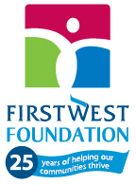

Enderby Financial Community Endowment
2021 Grants

Organization Name | 2021 Grant
Literacy Alliance of the Shuswap Society** | $6,025
Summer Literacy Program - Enderby is a 3-week summer literacy program aimed to engage lower-income kids in a fun supportive environment, designed to promote literacy, build community, and enhance self-esteem.
Enderby and District Community Resource Centre** | $17,893
Outreach Worker/Community Support Program provides direct support to families in the community, offering intense parenting support, referrals, crisis intervention, short-term counseling, and life skills. Funds seek to expand the current work arrangement with additional hours for program facilitator.
Kingfisher Interpretive Centre** | $5,025
Conservation Through Education provides an opportunity for local children (grades K-12) to educate and focus on our local environmental sustainability, ecosystem support and salmon lifecycle.
TOTAL |  | $28,943
**Organization has received funding in previous years

